UUID Generator API

🔑 What Is a UUID Generator API?
# Source: Chatgpt (GPT-5-Mini) at [1/19/2026]
A UUID Generator API is a simple web service that returns a Universally Unique Identifier (UUID) — a 128-bit string used to uniquely identify objects, users, sessions, transactions, etc.
UUIDs are useful when you need:
- Unique IDs for database records
- Random identifiers for tokens or sessions
- Tracking references in distributed systems

🧬 What Is a UUID?
# Source: Chatgpt (GPT-5-Mini) at [1/19/2026]
A UUID (Universally Unique Identifier) typically looks like:

550e8400-e29b-41d4-a716-446655440000

It has:
- 32 hexadecimal characters
- Divided into 5 sections (8-4-4-4-12)
- Generated randomly or using timestamp + MAC + other inputs

✅ What UUID Generator APIs Do
# Source: Chatgpt (GPT-5-Mini) at [1/19/2026]


Feature | Description
🔁 Generate UUID | Create new unique identifiers (v1, v4, etc.)
🔢 Specify version | Choose UUID v1 (time-based) or v4 (random)
🔃 Generate multiple | Get a batch of UUIDs in one call
🧪 Format options | Some APIs let you change output format (JSON, plain text)

🔗 Popular UUID Generator API Examples

✅ 1. UUIDTools API (Free, public)
# Source: Chatgpt (GPT-5-Mini) at [1/19/2026]
- URL:

https://www.uuidtools.com/api/generate/v4

- Returns:
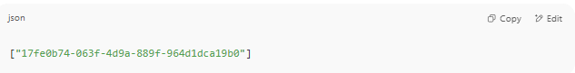
["17fe0b74-063f-4d9a-889f-964d1dca19b0"]

✅ 2. UUIDGenerator.net
# Source: Chatgpt (GPT-5-Mini) at [1/19/2026]
- URL:

https://www.uuidgenerator.net/api/version4

- Returns plain text UUID:

550e8400-e29b-41d4-a716-446655440000

✅ 3. RapidAPI - UUID API
# Source: Chatgpt (GPT-5-Mini) at [1/19/2026]
- https://rapidapi.com
- Supports multiple formats and bulk generation.

What Is Bulk Generation?
# Source: Chatgpt (GPT-5-Mini) at [1/19/2026]
Bulk generation means generating or producing many items at once, instead of just one at a time.

✅ In the context of UUID APIs (or other APIs):
Bulk generation = Requesting multiple UUIDs (or other values) in one API call.

🔍 Example:
🔹 Single UUID generation:

GET https://uuid.p.rapidapi.com/v1/uuid

Response: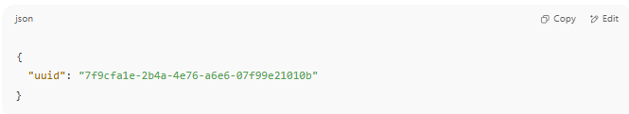
{
"uuid": "7f9cfa1e-2b4a-4e76-a6e6-07f99e21010b"
}

🔹 Bulk UUID generation (e.g., 5 UUIDs):

GET https://uuid.p.rapidapi.com/v1/bulk?count=5

Response:
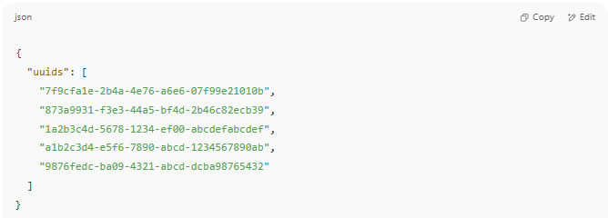

{
"uuids": [
"7f9cfa1e-2b4a-4e76-a6e6-07f99e21010b",
"873a9931-f3e3-44a5-bf4d-2b46c82ecb39",
"1a2b3c4d-5678-1234-ef00-abcdefabcdef",
"a1b2c3d4-e5f6-7890-abcd-1234567890ab",
"9876fedc-ba09-4321-abcd-dcba98765432"
]
}

🛠 Why Bulk Generation is Useful
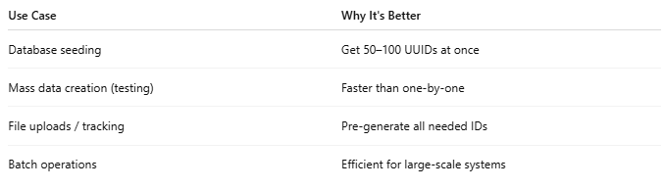

Use Case | Why It's Better
Database seeding | Get 50–100 UUIDs at once
Mass data creation (testing) | Faster than one-by-one
File uploads / tracking | Pre-generate all needed IDs
Batch operations | Efficient for large-scale systems

💡 Tip:
When calling APIs that support bulk generation, check for a count or number parameter like:
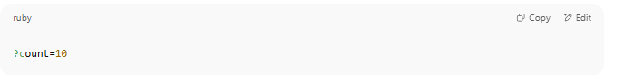
?count=10

That tells the API how many items to return in one call.

📤 Example (Single UUID with cURL)
# Source: Chatgpt (GPT-5-Mini) at [1/19/2026]

curl https://www.uuidgenerator.net/api/version4

Output:

2bc6f8ba-194d-4427-8c3d-7a1bd67efc0b

🧪 Example in JavaScript (fetch UUID):
# Source: Chatgpt (GPT-5-Mini) at [1/19/2026]

fetch('https://www.uuidgenerator.net/api/version4')
.then(res => res.text())
.then(id => console.log("Generated UUID:", id));

🛠 Use Cases for UUIDs
# Source: Chatgpt (GPT-5-Mini) at [1/19/2026]
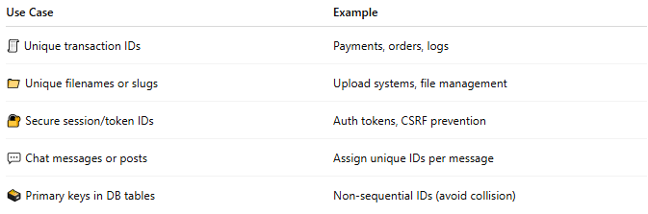

Use Case | Example
🧾 Unique transaction IDs | Payments, orders, logs
📁 Unique filenames or slugs | Upload systems, file management
🔐 Secure session/token IDs | Auth tokens, CSRF prevention
💬 Chat messages or posts | Assign unique IDs per message
🗃️ Primary keys in DB tables | Non-sequential IDs (avoid collision)

Is this really Universally Unique Identifier or fake
# Source: Chatgpt (GPT-5-Mini) at [1/19/2026]
Great question! Let’s break it down clearly:

✅ Is a UUID Really Unique?
# Source: Chatgpt (GPT-5-Mini) at [1/19/2026]

Yes — Practically, but Not Absolutely Guaranteed
A UUID (Universally Unique Identifier), especially Version 4 (UUIDv4) which is random-based, is designed to be so statistically unique that the chance of generating the same one twice is astronomically small.
🧮 A UUIDv4 has 2¹²² possible combinations
That’s about 5.3 × 10³⁶ unique values
(Compare: only ~10²⁴ stars in the observable universe)

🧪 UUID v4 Example:
# Source: Chatgpt (GPT-5-Mini) at [1/19/2026]

2bc6f8ba-194d-4427-8c3d-7a1bd67efc0b

This was generated randomly. The chance of collision? Virtually zero.

⚠️ Important to Know:
# Source: Chatgpt (GPT-5-Mini) at [1/19/2026]
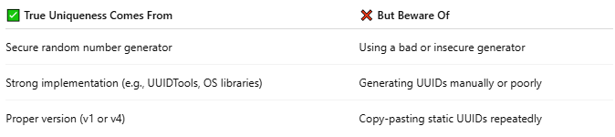

✅ True Uniqueness Comes From | ❌ But Beware Of
Secure random number generator | Using a bad or insecure generator
Strong implementation (e.g., UUIDTools, OS libraries) | Generating UUIDs manually or poorly
Proper version (v1 or v4) | Copy-pasting static UUIDs repeatedly
So if you use a trusted UUID API or built-in library, like:
- uuidtools.com
- uuidgenerator.net
- Programming libs (uuid in Python/Node.js/Java)
→ You are safe.

❌ What Would Make It “Fake”?
# Source: Chatgpt (GPT-5-Mini) at [1/19/2026]
A UUID is not unique if:
- It's hardcoded or reused
- Generated by a non-random source
- Comes from a mock or low-quality service

✅ Best Practices
# Source: Chatgpt (GPT-5-Mini) at [1/19/2026]
- Use UUIDv4 for most general purposes (random-based)
- Use UUIDv1 if you want time + MAC-based tracking (traceable)
- Use trusted APIs or cryptographic libraries to generate them
- NEVER generate UUIDs using something like Math.random() in JavaScript for secure usage

🧠 Summary
# Source: Chatgpt (GPT-5-Mini) at [1/19/2026]


Question | Answer
Is UUID 100% globally unique? | No — but statistically, yes
Safe for use as primary keys or tokens? | ✅ Yes, when generated properly
Can you ever get a duplicate? | Theoretically yes, but in practice no

Example
# Source: Windows ScreenShots at [1/19/2026]

https://www.uuidtools.com/api/generate/v4
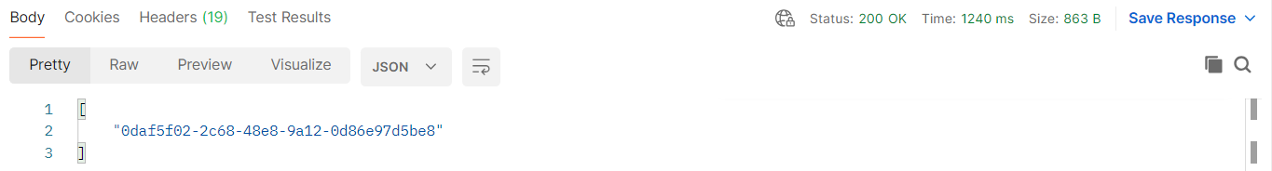


https://www.uuidgenerator.net/api/version4

